Project Design Phase-II Technology Stack (Architecture & Stack)

Date | 11 October 2026
Team ID | ServiceNow - A2
Project Name | Car Rental Request Automation in ServiceNow
Maximum Marks | 4 Marks

Technical Architecture:
The Deliverable shall include the architectural diagram as below and the information as per the table1 & table 2

Example: Order processing during pandemics for offline mode
Reference: https://developer.ibm.com/patterns/ai-powered-backend-system-for-order-processing-during-pandemics/
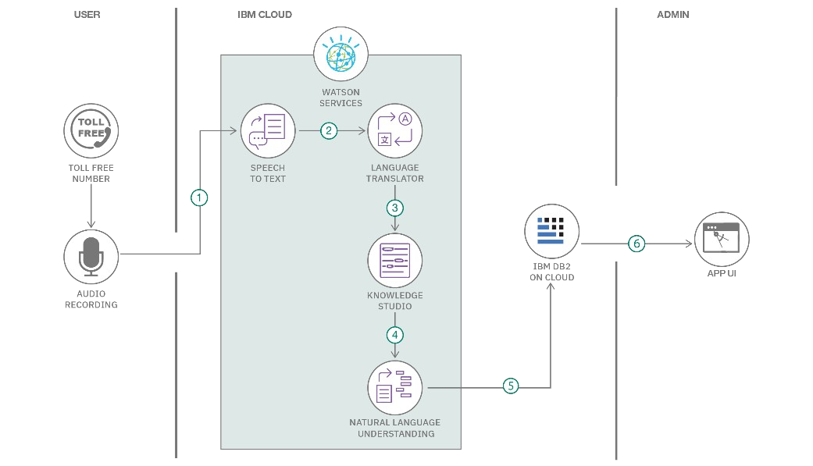
Guidelines:
Include all the processes (As an application logic / Technology Block)
Provide infrastructural demarcation (Local / Cloud) Indicate external interfaces (third party API’s etc.) Indicate Data Storage components / services Indicate interface to machine learning models (if
applicable)

Table-1 : Components & Technologies:

S.No | Component | Description | Technology
1 | User Interface | Employee-facing catalog item and request form. | ServiceNow Service Catalog / Catalog Item
2 | Request Management | Creates and tracks the service request and Requested Item (RITM). | ServiceNow Request Management
3 | Automation Logic | Controls validation, approval, assignment and fulfillment stages. | Flow Designer / Workflow
4 | Approval Management | Routes requests to the appropriate approver and records the  decision. | ServiceNow Approvals
5 | Assignment & Fulfillment | Routes approved requests to the Transport team and records  fulfillment information. | Assignment Groups / RITM
6 | Notifications | Sends request and status updates to relevant users. | ServiceNow Notifications
7 | Data Storage | Stores request, variable, approval, assignment and task  information. | ServiceNow Platform Database
8 | Access Control | Controls access using roles, ACLs and platform permissions. | ServiceNow Roles / ACLs
9 | Deployment | Moves configuration between instances for testing and  deployment. | Update Sets

Table-2: Application Characteristics:

S.No | Characteristics | Description | Technology
1 | Open-Source Frameworks | No separate open-source application framework is required for the  core solution; ServiceNow platform capabilities are used. | ServiceNow
2 | Security Implementations | Role-based access, ACLs, authentication and controlled access to  catalog, request and fulfillment records. | ServiceNow Roles / ACLs
3 | Scalable Architecture | Supports additional request variables, approval stages and  fulfillment rules as demand grows. | ServiceNow Platform
4 | Availability | Cloud-hosted ServiceNow platform provides access to the catalog  and request records according to platform availability. | ServiceNow
5 | Performance | Use mandatory fields, efficient flow conditions and targeted  notifications to minimize unnecessary processing. | Flow Designer / ServiceNow

References:

https://c4model.com/
https://developer.ibm.com/patterns/online-order-processing-system-during-pandemic/ https://www.ibm.com/cloud/architecture
https://aws.amazon.com/architecture
https://medium.com/the-internal-startup/how-to-draw-useful-technical-architecture-diagrams-2d20c9fda90d

Technical Architecture – Car Rental Request Automation
The architecture uses ServiceNow as the central platform. The employee interacts with the Service Catalog; ServiceNow creates and manages the request/RITM, executes Flow Designer or Workflow automation, routes approvals and assignments, stores request information and sends notifications.

High-Level Architecture Flow

EMPLOYEE / REQUESTER
↓
ServiceNow Service Catalog – Car Rental Request
↓
Catalog Variables → Request / Requested Item (RITM)
↓
Flow Designer / Workflow
- Validation → Approval → Assignment
↓
Transport Team
* Availability Check → Fulfillment Details → Completion
↓
Notifications & Status Tracking
- Requester / Approver / Transport Team

Table-1: Components & Technologies

Table-2: Application Characteristics References
- ServiceNow Service Catalog documentation
- ServiceNow Flow Designer documentation
- ServiceNow Request / Requested Item (RITM) documentation
- ServiceNow Access Control (ACL) documentation

